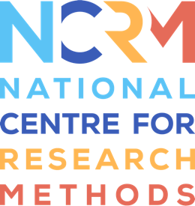
Generative AI Tools for Quantitative Research

Video 1 transcript

Video: https://youtu.be/PptcADMEoiA

David Bann: Hello, my name is David Bann. I’m going to show you a series of videos showing you how to use AI and large language models, in particular to help your coding tasks in quantitative research.
In the first video, we’re going to be obtaining code by chatbots. We’re going to obtain Stata and R syntax to conduct descriptive analyses and analyse association between variables. We’re going to use multiple LLMs. We’re going to be using cloud providers; that’s websites, the GPT series of models, closed weight models, and also open weight models, the DeepSeek model. We’re finally going to use, for the same task, we’re going to use a local large language model like the Ollama application.
So in this first part, we’ll be using the ChatGPT application, and here we are requesting that code in R format, and we can see that the code and the comments, as well as guidance is outputted below from the large language model. We’re now requesting the same in Stata format and the LLM rapidly outputs feasible looking code in Stata formats.
Now the same request using the DeepSeek website, firstly requesting R syntax, then you can see the LLM is rapidly outputting code in R syntax format, for us to conduct the analyses that we requested.
And finally we’re switching to the Ollama application using the Gemma model. This is using a local large language model which does not require internet access, and this is a four billion parameter model, so it’s not as powerful as the cloud providers, but we can see that it does provide credible code in R. This small local large language model also providers helpful guidance and comments on our code as well.
And finally we request the same code but in Stata format. For all of the code that’s outputted, it’s worth bearing in mind that you can request revisions or you can ask the large language model to fix the code if it isn’t working, in the same ways as you would speak to a colleague and request revisions on their work.

National Centre for Research Methods (NCRM)
Social Sciences
Murray Building (Bldg 58)
University of Southampton
Southampton SO17 1BJ
United Kingdom
Web www.ncrm.ac.uk
Email info@ncrm.ac.uk
Tel +44 23 8059 4539
Twitter @NCRMUK

